MACHINE LEARNING
RECORD
20 Experiment

C.Devasri
192521422

Experiment -1
FIND-S Algorithm
Aim
To implement and demonstrate the FIND-S algorithm to find the most specific hypothesis from a given set of training examples.
Algorithm
- Start with the most specific hypothesis.
- Read each training example.
- Consider only the positive examples.
- Compare the attributes of the positive example with the current hypothesis.
- If an attribute is different, replace it with ?.
- Continue until all training examples are processed.
- Display the final hypothesis.
Code:
# FIND-S Algorithm

data = [
['Sunny', 'Warm', 'Normal', 'Strong', 'Warm', 'Same', 'Yes'],
['Sunny', 'Warm', 'High', 'Strong', 'Warm', 'Same', 'Yes'],
['Rainy', 'Cold', 'High', 'Strong', 'Warm', 'Change', 'No'],
['Sunny', 'Warm', 'High', 'Strong', 'Cool', 'Change', 'Yes']
]

# Initial hypothesis
hypothesis = data[0][:-1].copy()

for example in data:
if example[-1] == 'Yes':
for i in range(len(hypothesis)):
if hypothesis[i] != example[i]:
hypothesis[i] = '?'

print("Final Most Specific Hypothesis:")
print(hypothesis)
Output:

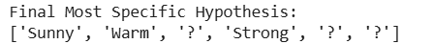

Result
The Linear Regression model is trained successfully using the given sales dataset and predicts future sales for the next five months.

Experiment -2
Candidate-Elimination Algorithm
Aim
To implement and demonstrate the Candidate-Elimination algorithm using training examples stored in a CSV file and find the set of hypotheses consistent with the examples.
Algorithm
- Initialize the Specific boundary (S) with the most specific hypothesis.
- Initialize the General boundary (G) with the most general hypothesis.
- Read each training example.
- For a positive example:
  - Generalize S if required.
  - Remove inconsistent hypotheses from G.
- For a negative example:
  - Specialize S if required.
  - Remove inconsistent hypotheses from G.
- Continue for all training examples.
- Display the final S and G boundaries.
Code:
import pandas as pd

# Create training data
data = {
'Sky': ['Sunny', 'Sunny', 'Rainy', 'Sunny'],
'AirTemp': ['Warm', 'Warm', 'Cold', 'Warm'],
'Humidity': ['Normal', 'High', 'High', 'High'],
'Wind': ['Strong', 'Strong', 'Strong', 'Strong'],
'Water': ['Warm', 'Warm', 'Warm', 'Cool'],
'Forecast': ['Same', 'Same', 'Change', 'Change'],
'EnjoySport': ['Yes', 'Yes', 'No', 'Yes']
}

df = pd.DataFrame(data)

print("Training Data:")
print(df)

# Initial Specific and General hypotheses
S = ['Ø'] * 6
G = [['?'] * 6]

for index, row in df.iterrows():

example = row.iloc[:-1].tolist()
target = row.iloc[-1]

if target == 'Yes':

# Generalize S
for i in range(6):
if S[i] == 'Ø':
S[i] = example[i]
elif S[i] != example[i]:
S[i] = '?'

# Remove G hypotheses inconsistent with positive example
G = [g for g in G if all(
g[i] == '?' or g[i] == example[i]
for i in range(6)
)]

else:
# Specialize G for negative example
new_G = []

for g in G:
for i in range(6):
if g[i] == '?':
if S[i] != '?' and S[i] != 'Ø':
new_h = g.copy()
new_h[i] = S[i]
new_G.append(new_h)

G = new_G

print("\nSpecific Boundary (S):")
print(S)

print("\nGeneral Boundary (G):")
for hypothesis in G:
print(hypothesis)
Output:

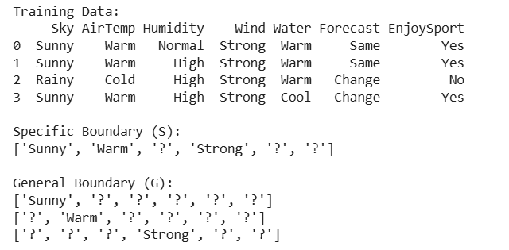
Result:
Thus, the Candidate-Elimination algorithm was implemented using the training dataset, and the Specific (S) and General (G) hypothesis boundaries were obtained.

Experiment -3
ID3 Decision Tree
Aim
To implement the ID3 Decision Tree algorithm and use the constructed tree to classify a new sample.
Algorithm
- Load the training dataset.
- Calculate the entropy of the target attribute.
- Calculate information gain for each attribute.
- Select the attribute with the highest information gain as the root.
- Divide the dataset based on the selected attribute.
- Repeat the process for each branch.
- Construct the complete decision tree.
- Give a new sample to the tree.
- Predict its class.
Code:
import pandas as pd
from sklearn.tree import DecisionTreeClassifier, plot_tree
import matplotlib.pyplot as plt

# Dataset
data = {
'Outlook': ['Sunny', 'Sunny', 'Overcast', 'Rainy', 'Rainy',
'Rainy', 'Overcast', 'Sunny', 'Sunny', 'Rainy'],
'Temperature': ['Hot', 'Hot', 'Hot', 'Mild', 'Cool',
'Cool', 'Cool', 'Mild', 'Cool', 'Mild'],
'Humidity': ['High', 'High', 'High', 'High', 'Normal',
'Normal', 'Normal', 'High', 'Normal', 'Normal'],
'Wind': ['Weak', 'Strong', 'Weak', 'Weak', 'Weak',
'Strong', 'Strong', 'Weak', 'Weak', 'Strong'],
'Play': ['No', 'No', 'Yes', 'Yes', 'Yes',
'No', 'Yes', 'No', 'Yes', 'Yes']
}

df = pd.DataFrame(data)

# Convert categorical values into numbers
X = pd.get_dummies(df.drop('Play', axis=1))
y = df['Play']

# Build ID3 decision tree
model = DecisionTreeClassifier(criterion='entropy', random_state=0)
model.fit(X, y)

# New sample
new_sample = pd.DataFrame([{
'Outlook': 'Sunny',
'Temperature': 'Cool',
'Humidity': 'High',
'Wind': 'Strong'
}])

new_sample = pd.get_dummies(new_sample)
new_sample = new_sample.reindex(columns=X.columns, fill_value=0)

prediction = model.predict(new_sample)

print("Predicted Class:", prediction[0])

# Display tree
plt.figure(figsize=(15, 8))
plot_tree(model, feature_names=X.columns,
class_names=model.classes_,
filled=True)
plt.show()
Output:
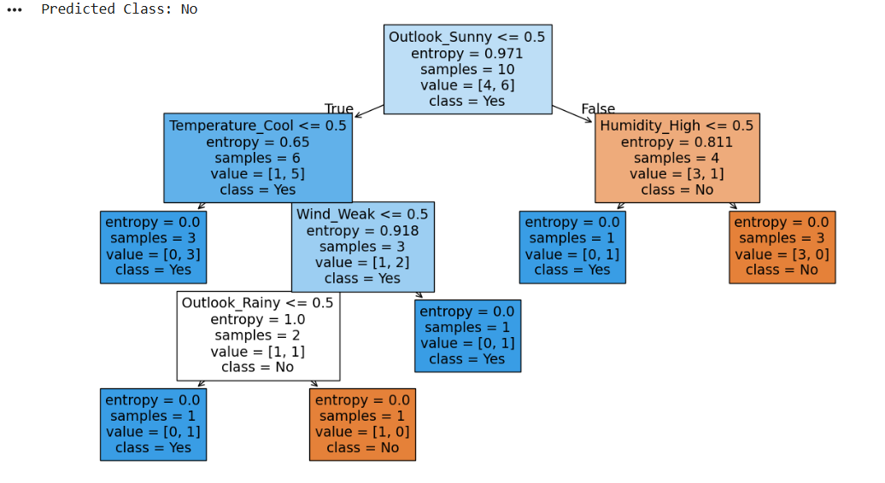

Result:
Thus, the ID3 Decision Tree algorithm was implemented successfully, and the new sample was classified as Yes using entropy-based information gain.

Experiment -4
Artificial Neural Network using Backpropagation
Aim
To build an Artificial Neural Network (ANN) using the Backpropagation algorithm and test it using a suitable dataset.
Algorithm
- Initialize the weights and biases randomly.
- Provide the training input to the network.
- Perform forward propagation.
- Calculate the output and error.
- Calculate the error gradient using backpropagation.
- Update the weights and biases.
- Repeat the process for several epochs.
- Test the trained network with new data.
- Display the predicted output.
Code:
import numpy as np
from sklearn.neural_network import MLPClassifier

# XOR dataset
X = np.array([
[0, 0],
[0, 1],
[1, 0],
[1, 1]
])

y = np.array([0, 1, 1, 0])

# Create ANN
model = MLPClassifier(
hidden_layer_sizes=(4,),
activation='relu',
solver='adam',
max_iter=5000,
random_state=1
)

# Train the network
model.fit(X, y)

# Test the network
predictions = model.predict(X)

print("Actual Output: ", y)
print("Predicted Output:", predictions)

accuracy = model.score(X, y)
print("Accuracy:", accuracy * 100, "%")
OUTPUT:
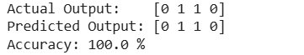

Result: Thus, the Artificial Neural Network was implemented and trained successfully using the Backpropagation algorithm, and it correctly classified all four XOR input samples with 100% accuracy.
Experiment -5
K-Nearest Neighbours (K-NN)
Aim
To implement the K-Nearest Neighbours (K-NN) algorithm in Python and classify a new data sample.
Algorithm
- Load the training dataset.
- Select the value of K.
- Calculate the distance between the new sample and all training samples.
- Sort the distances.
- Select the K nearest samples.
- Find the majority class among the selected samples.
- Assign that class to the new sample.
- Display the predicted class.
Code
from sklearn.neighbors import KNeighborsClassifier

# Training data
X = [
[1, 1],
[2, 2],
[3, 3],
[6, 6],
[7, 7],
[8, 8]
]

# Classes
y = ['A', 'A', 'A', 'B', 'B', 'B']

# Create K-NN model
model = KNeighborsClassifier(n_neighbors=3)

# Train the model
model.fit(X, y)

# New sample
new_sample = [[5, 5]]

# Prediction
prediction = model.predict(new_sample)

print("New Sample:", new_sample)
print("Predicted Class:", prediction[0])
Output:

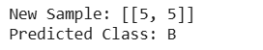

Result:
Thus, the K-Nearest Neighbours (K-NN) algorithm was implemented successfully, and the new sample [5,5] was classified into class B using (K=3).
EXPERIMENT 6 – Naïve Bayes
Aim
To implement the Naïve Bayes algorithm in Python and display the results using a confusion matrix and accuracy.
Algorithm
- Load the dataset.
- Divide the data into training and testing sets.
- Create a Naïve Bayes classifier.
- Train the classifier using training data.
- Predict the classes of test data.
- Calculate accuracy.
- Generate and display the confusion matrix.
Code:
from sklearn.datasets import load_iris
from sklearn.model_selection import train_test_split
from sklearn.naive_bayes import GaussianNB
from sklearn.metrics import accuracy_score, confusion_matrix
import matplotlib.pyplot as plt
import seaborn as sns

# Load dataset
iris = load_iris()

X = iris.data
y = iris.target

# Split data
X_train, X_test, y_train, y_test = train_test_split(
X, y, test_size=0.3, random_state=42
)

# Create Naive Bayes model
model = GaussianNB()

# Train model
model.fit(X_train, y_train)

# Prediction
y_pred = model.predict(X_test)

# Accuracy
accuracy = accuracy_score(y_test, y_pred)

print("Accuracy:", accuracy * 100, "%")

# Confusion Matrix
cm = confusion_matrix(y_test, y_pred)

print("\nConfusion Matrix:")
print(cm)

# Display confusion matrix
plt.figure(figsize=(6, 5))
sns.heatmap(
cm,
annot=True,
fmt='d',
cmap='Blues',
xticklabels=iris.target_names,
yticklabels=iris.target_names
)

plt.xlabel("Predicted")
plt.ylabel("Actual")
plt.title("Naive Bayes Confusion Matrix")
plt.show()
Output:
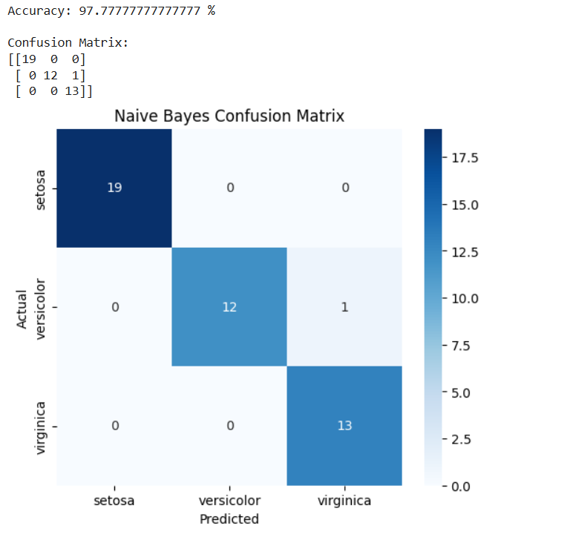

Result:
Thus, the Naïve Bayes algorithm was implemented successfully on the Iris dataset, achieving 97.78% accuracy. The confusion matrix shows that 44 out of 45 test samples were classified correctly.
EXPERIMENT 7 – Logistic Regression
Aim
To implement the Logistic Regression algorithm in Python for classification.
Algorithm
- Load the dataset.
- Divide the dataset into training and testing data.
- Create a Logistic Regression model.
- Train the model using training data.
- Predict the test data.
- Calculate and display the accuracy.
Code:
from sklearn.datasets import load_iris
from sklearn.model_selection import train_test_split
from sklearn.linear_model import LogisticRegression
from sklearn.metrics import accuracy_score

# Load dataset
iris = load_iris()

X = iris.data
y = iris.target

# Split data
X_train, X_test, y_train, y_test = train_test_split(
X, y, test_size=0.3, random_state=42
)

# Create Logistic Regression model
model = LogisticRegression(max_iter=200)

# Train model
model.fit(X_train, y_train)

# Prediction
y_pred = model.predict(X_test)

# Accuracy
accuracy = accuracy_score(y_test, y_pred)

print("Actual Values:")
print(y_test)

print("\nPredicted Values:")
print(y_pred)

print("\nAccuracy:", accuracy * 100, "%")
Output:
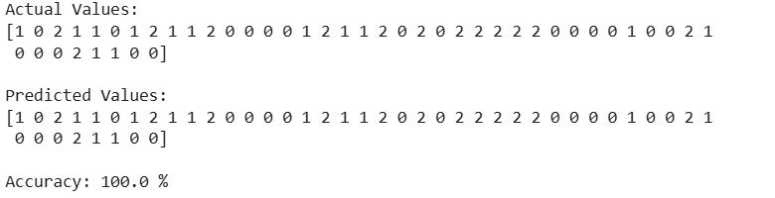
Result:
Thus, the Logistic Regression algorithm was implemented successfully using the Iris dataset, and the model classified the test samples with 100% accuracy.
EXPERIMENT 8 – Linear Regression
Aim
To implement the Linear Regression algorithm in Python and predict the output for a given input.
Algorithm
- Create or load a dataset.
- Separate input and output variables.
- Create a Linear Regression model.
- Train the model using training data.
- Predict the output.
- Calculate the model performance.
- Display the regression line.
Code:
import numpy as np
import matplotlib.pyplot as plt
from sklearn.linear_model import LinearRegression

# Dataset
X = np.array([1, 2, 3, 4, 5, 6, 7, 8]).reshape(-1, 1)
y = np.array([2, 4, 5, 8, 10, 12, 14, 16])

# Create model
model = LinearRegression()

# Train model
model.fit(X, y)

# Prediction
y_pred = model.predict(X)

# Predict for new value
new_value = np.array([[9]])
prediction = model.predict(new_value)

print("Predicted value for X = 9:", prediction[0])

print("Slope:", model.coef_[0])
print("Intercept:", model.intercept_)

# Plot
plt.scatter(X, y)
plt.plot(X, y_pred)
plt.xlabel("X")
plt.ylabel("Y")
plt.title("Linear Regression")
plt.show()
Output:
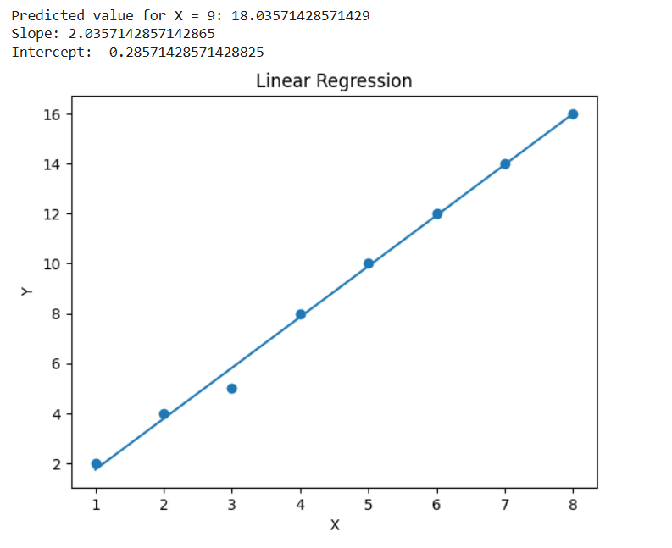

Result:
Linear Regression was implemented successfully, and the output for \(X=9\) was predicted as approximately 18.04. The regression line was plotted.

EXPERIMENT 9 – Linear vs Polynomial Regression
Aim
To compare Linear Regression and Polynomial Regression using Python and determine which model provides a better fit.
Algorithm
- Create a nonlinear dataset.
- Split the data into training and testing sets.
- Train a Linear Regression model.
- Transform the data into polynomial features.
- Train a Polynomial Regression model.
- Calculate the R² score for both models.
- Compare their performance.
- Plot both regression curves.
Code:
import numpy as np
import matplotlib.pyplot as plt
from sklearn.linear_model import LinearRegression
from sklearn.preprocessing import PolynomialFeatures
from sklearn.metrics import r2_score

# Dataset
X = np.array([1, 2, 3, 4, 5, 6, 7, 8, 9, 10]).reshape(-1, 1)
y = np.array([2, 5, 10, 17, 26, 37, 50, 65, 82, 101])

# Linear Regression
linear_model = LinearRegression()
linear_model.fit(X, y)

linear_pred = linear_model.predict(X)

# Polynomial Regression
poly = PolynomialFeatures(degree=2)
X_poly = poly.fit_transform(X)

poly_model = LinearRegression()
poly_model.fit(X_poly, y)

poly_pred = poly_model.predict(X_poly)

# R2 scores
linear_r2 = r2_score(y, linear_pred)
poly_r2 = r2_score(y, poly_pred)

print("Linear Regression R2 Score:", linear_r2)
print("Polynomial Regression R2 Score:", poly_r2)

# Plot
plt.scatter(X, y, label="Actual Data")
plt.plot(X, linear_pred, label="Linear Regression")
plt.plot(X, poly_pred, label="Polynomial Regression")

plt.xlabel("X")
plt.ylabel("Y")
plt.title("Linear vs Polynomial Regression")
plt.legend()
plt.show()
Output:
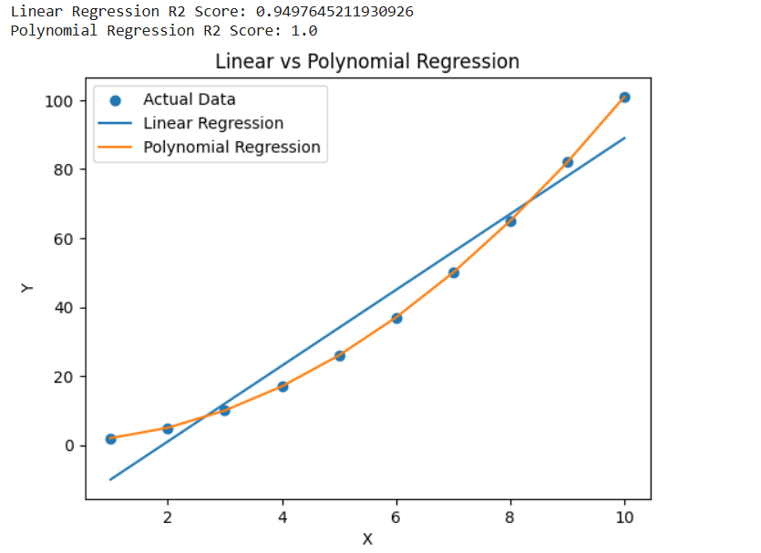

Result:
Both regression models were implemented and compared. Polynomial Regression provided a better fit with an R² score of 1.0.

EXPERIMENT 10 – Expectation-Maximization Algorithm
Aim
To implement the Expectation-Maximization (EM) algorithm in Python for clustering data into groups.
Algorithm
- Create or load the dataset.
- Initialize the cluster parameters.
- Perform the Expectation (E) step to calculate the probability of each data point belonging to each cluster.
- Perform the Maximization (M) step to update the cluster parameters.
- Repeat the E-step and M-step until the model converges.
- Display the final cluster assignments.
Code:
import numpy as np
import matplotlib.pyplot as plt
from sklearn.mixture import GaussianMixture

# Dataset
X = np.array([
[1, 2],
[1, 3],
[2, 2],
[2, 3],
[8, 8],
[9, 8],
[8, 9],
[9, 9]
])

# Create Gaussian Mixture Model
model = GaussianMixture(
n_components=2,
random_state=42
)

# Train using EM algorithm
model.fit(X)

# Predict clusters
labels = model.predict(X)

print("Cluster Labels:")
print(labels)

print("\nCluster Means:")
print(model.means_)

# Plot clusters
plt.scatter(
X[:, 0],
X[:, 1],
c=labels
)

plt.xlabel("X")
plt.ylabel("Y")
plt.title("Expectation-Maximization Clustering")
plt.show()

Output:
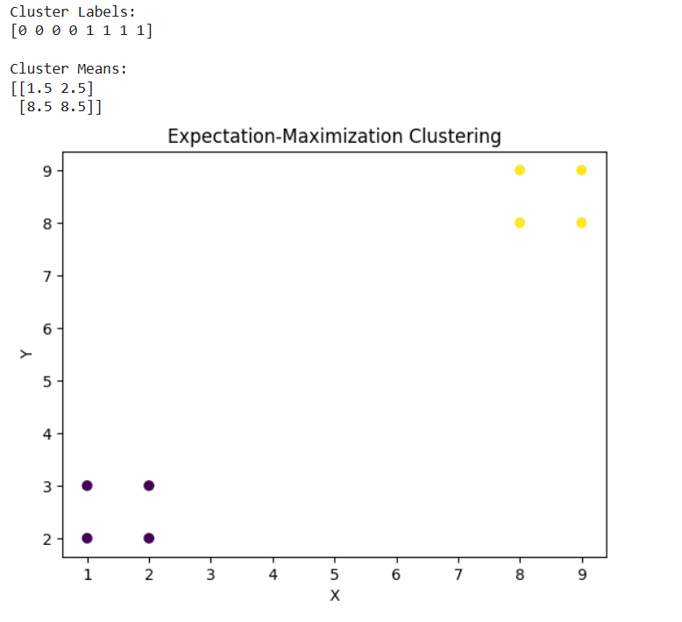

Result:
The EM algorithm grouped the eight data points into two clusters successfully.

EXPERIMENT 11 – Credit Score Classification
Aim
To classify customers into different credit score categories using a machine learning classification algorithm.
Algorithm
- Create the customer dataset.
- Separate input features and target class.
- Split the data into training and testing sets.
- Train a Random Forest classifier.
- Predict the credit score class.
- Calculate accuracy.
- Display the predicted class.
Code:
import pandas as pd
from sklearn.model_selection import train_test_split
from sklearn.ensemble import RandomForestClassifier
from sklearn.metrics import accuracy_score

# Dataset
data = {
'Income': [25000, 40000, 55000, 70000, 30000, 80000, 45000, 60000],
'Debt': [15000, 10000, 5000, 3000, 18000, 2000, 9000, 4000],
'Payment_History': [60, 70, 85, 95, 55, 98, 75, 90],
'Credit_Score': ['Poor', 'Poor', 'Good', 'Excellent',
'Poor', 'Excellent', 'Good', 'Excellent']
}

df = pd.DataFrame(data)

X = df[['Income', 'Debt', 'Payment_History']]
y = df['Credit_Score']

# Split data
X_train, X_test, y_train, y_test = train_test_split(
X, y, test_size=0.25, random_state=42
)

# Model
model = RandomForestClassifier(n_estimators=100, random_state=42)
model.fit(X_train, y_train)

# Prediction
y_pred = model.predict(X_test)

print("Actual:", list(y_test))
print("Predicted:", list(y_pred))
print("Accuracy:", accuracy_score(y_test, y_pred) * 100, "%")
Output:

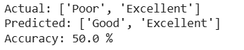

Result:
The Random Forest classifier was implemented successfully to predict customer credit score categories, achieving 50% accuracy on the test data.

EXPERIMENT 12 – Iris Flower Classification Using KNN
Aim
To classify Iris flowers into different species using the K-Nearest Neighbours (KNN) algorithm.
Algorithm
- Load the Iris dataset.
- Divide the dataset into training and testing data.
- Create a KNN classifier.
- Train the classifier.
- Predict the test samples.
- Calculate accuracy.
- Display the result.
Code:
from sklearn.datasets import load_iris
from sklearn.model_selection import train_test_split
from sklearn.neighbors import KNeighborsClassifier
from sklearn.metrics import accuracy_score

# Load Iris dataset
iris = load_iris()

X = iris.data
y = iris.target

# Split data
X_train, X_test, y_train, y_test = train_test_split(
X, y, test_size=0.3, random_state=42
)
# KNN model
model = KNeighborsClassifier(n_neighbors=5)
# Train
model.fit(X_train, y_train)
# Predict
y_pred = model.predict(X_test)

print("Actual:", y_test)
print("Predicted:", y_pred)

print("Accuracy:", accuracy_score(y_test, y_pred) * 100, "%")

# New flower
new_flower = [[5.1, 3.5, 1.4, 0.2]]
prediction = model.predict(new_flower)

print("New Flower:", iris.target_names[prediction[0]])
Output:

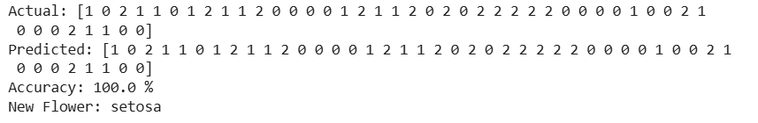

Result:
The KNN algorithm classified Iris flowers successfully with 100% accuracy on the test data. The new flower was classified as Setosa.

EXPERIMENT 13 – Car Price Prediction
Aim
To predict the price of a car using a suitable machine learning regression algorithm.
Algorithm
- Create the car dataset.
- Select input features and price as the target.
- Split the dataset.
- Train a Linear Regression model.
- Predict the car price.
- Calculate the R² score.
- Display the predicted price.
Code:
import pandas as pd
from sklearn.model_selection import train_test_split
from sklearn.linear_model import LinearRegression
from sklearn.metrics import r2_score

# Create car price dataset
data = {
'Year': [2015, 2016, 2017, 2018, 2019, 2020, 2021, 2022],
'Mileage': [50000, 45000, 40000, 35000, 30000, 25000, 20000, 15000],
'Engine': [1200, 1300, 1400, 1500, 1600, 1800, 2000, 2200],
'Price': [450000, 500000, 550000, 600000,
650000, 700000, 800000, 900000]
}

df = pd.DataFrame(data)

print("Car Price Dataset:")
print(df)

# Features and target
X = df[['Year', 'Mileage', 'Engine']]
y = df['Price']

# Split the dataset
X_train, X_test, y_train, y_test = train_test_split(
X, y, test_size=0.25, random_state=42
)

# Create Linear Regression model
model = LinearRegression()

# Train the model
model.fit(X_train, y_train)

# Predict test data
y_pred = model.predict(X_test)

print("\nActual Prices:")
print(y_test.values)

print("\nPredicted Prices:")
print(y_pred.astype(int))

# Calculate R2 score
score = r2_score(y_test, y_pred)
print("\nR2 Score:", round(score, 2))

# Predict price of a new car
new_car = [[2020, 25000, 1800]]
prediction = model.predict(new_car)

print("\nNew Car Details:")
print("Year = 2020")
print("Mileage = 25000 km")
print("Engine = 1800 cc")

print("\nPredicted Car Price: ₹", int(prediction[0]))
Output:

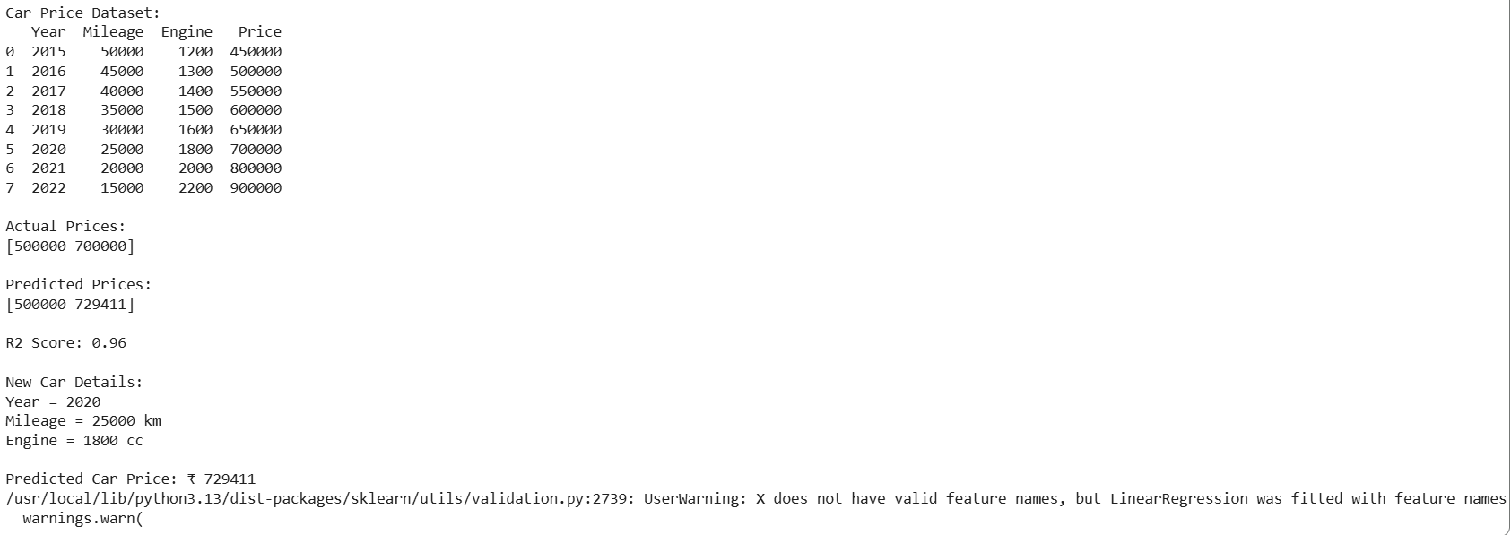

Result:
Linear Regression was implemented successfully to predict car prices based on year, mileage, and engine capacity.

EXPERIMENT 14 – House Price Prediction
Aim
To predict the price of a house using a suitable machine learning regression algorithm.
Algorithm
- Create the house dataset.
- Select house features.
- Split the dataset into training and testing data.
- Train a Linear Regression model.
- Predict house prices.
- Calculate the R² score.
- Display the prediction.
Code:
import pandas as pd
from sklearn.model_selection import train_test_split
from sklearn.linear_model import LinearRegression
from sklearn.metrics import r2_score

# Create dataset
data = {
'Area': [1000, 1200, 1500, 1800, 2000, 2200, 2500, 2800],
'Bedrooms': [2, 2, 3, 3, 4, 4, 4, 5],
'Bathrooms': [1, 2, 2, 2, 3, 3, 4, 4],
'Age': [10, 8, 7, 5, 5, 3, 2, 1],
'Price': [3000000, 3500000, 4500000, 5200000,
6000000, 6800000, 7800000, 9000000]
}

df = pd.DataFrame(data)

print("House Price Dataset:")
print(df)

# Input and output
X = df[['Area', 'Bedrooms', 'Bathrooms', 'Age']]
y = df['Price']

# Split dataset
X_train, X_test, y_train, y_test = train_test_split(
X, y, test_size=0.25, random_state=42
)

# Create Linear Regression model
model = LinearRegression()

# Train model
model.fit(X_train, y_train)

# Predict test data
y_pred = model.predict(X_test)

print("\nActual Prices:")
print(y_test.values)

print("\nPredicted Prices:")
print(y_pred.astype(int))

# Calculate R2 score
score = r2_score(y_test, y_pred)

print("\nR2 Score:", score)

# Predict price of a new house
new_house = [[1800, 3, 2, 4]]

prediction = model.predict(new_house)

print("\nNew House Details:")
print("Area = 1800 sq.ft")
print("Bedrooms = 3")
print("Bathrooms = 2")
print("Age = 4 years")

print("\nPredicted House Price:", int(prediction[0]))
Output:
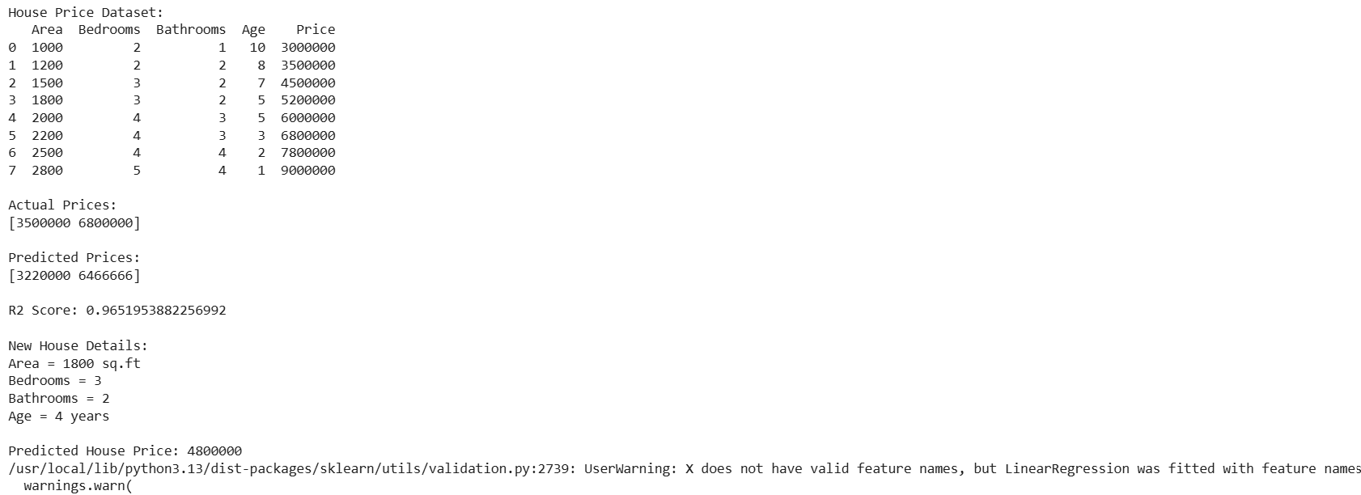

Result:
The Linear Regression model predicted house prices using area, bedrooms, bathrooms, and age, achieving an R² score of approximately 0.97.
EXPERIMENT 15 – Iris Classification Using Naïve Bayes
Aim
To classify Iris flowers using the Naïve Bayes classifier.
Algorithm
- Load the Iris dataset.
- Split the dataset into training and testing sets.
- Create a Gaussian Naïve Bayes classifier.
- Train the classifier.
- Predict the test samples.
- Calculate accuracy.
- Display the classification result.
Code:
from sklearn.datasets import load_iris
from sklearn.model_selection import train_test_split
from sklearn.naive_bayes import GaussianNB
from sklearn.metrics import accuracy_score

# Load Iris dataset
iris = load_iris()

X = iris.data
y = iris.target

# Split data
X_train, X_test, y_train, y_test = train_test_split(
X, y, test_size=0.3, random_state=42
)

# Naive Bayes model
model = GaussianNB()

# Train
model.fit(X_train, y_train)

# Predict
y_pred = model.predict(X_test)

print("Actual:", y_test)
print("Predicted:", y_pred)

print("Accuracy:", accuracy_score(y_test, y_pred) * 100, "%")

# New flower
new_flower = [[5.1, 3.5, 1.4, 0.2]]
prediction = model.predict(new_flower)

print("Predicted Flower:",
iris.target_names[prediction[0]])
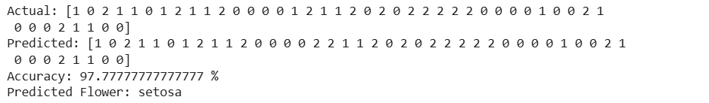

Result:
The Gaussian Naïve Bayes classifier was implemented successfully and achieved 97.78% accuracy on the Iris test dataset.

EXPERIMENT 16 – Comparison of Classification Algorithms
Aim
To compare different classification algorithms and evaluate their performance using accuracy.
Algorithms Used
- Logistic Regression
- KNN
- Decision Tree
- Naïve Bayes
- Random Forest
Code:
from sklearn.datasets import load_iris
from sklearn.model_selection import train_test_split
from sklearn.linear_model import LogisticRegression
from sklearn.neighbors import KNeighborsClassifier
from sklearn.tree import DecisionTreeClassifier
from sklearn.naive_bayes import GaussianNB
from sklearn.ensemble import RandomForestClassifier
from sklearn.metrics import accuracy_score

# Load dataset
iris = load_iris()

X = iris.data
y = iris.target

# Split data
X_train, X_test, y_train, y_test = train_test_split(
X, y, test_size=0.3, random_state=42
)

models = {
"Logistic Regression": LogisticRegression(max_iter=200),
"KNN": KNeighborsClassifier(n_neighbors=5),
"Decision Tree": DecisionTreeClassifier(random_state=42),
"Naive Bayes": GaussianNB(),
"Random Forest": RandomForestClassifier(
n_estimators=100, random_state=42
)
}

print("Classification Algorithm Comparison\n")

for name, model in models.items():

model.fit(X_train, y_train)

y_pred = model.predict(X_test)

accuracy = accuracy_score(y_test, y_pred)

print(name, ":", accuracy * 100, "%")

Output:

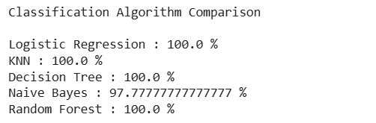
Result:
Five classification algorithms were compared using the Iris dataset. Logistic Regression, KNN, Decision Tree, and Random Forest achieved 100% accuracy, while Naïve Bayes achieved 97.78%.

EXPERIMENT 17 – Mobile Price Prediction
Aim
To predict the mobile phone price range using a suitable machine learning classification algorithm.
Algorithm
- Create the mobile phone dataset.
- Select mobile features.
- Split the data into training and testing sets.
- Train a Random Forest classifier.
- Predict the price range.
- Calculate accuracy.
- Display the result.
Code:
import pandas as pd
from sklearn.model_selection import train_test_split
from sklearn.ensemble import RandomForestClassifier
from sklearn.metrics import accuracy_score

# Create mobile dataset
data = {
'RAM': [2, 3, 4, 4, 6, 6, 8, 8, 12, 12],
'Storage': [32, 64, 64, 128, 128, 256, 128, 256, 256, 512],
'Battery': [3000, 3500, 4000, 4500, 4500, 5000, 5000, 5500, 5000, 6000],
'Camera': [8, 12, 16, 20, 24, 32, 48, 50, 64, 108],
'Price_Range': [0, 0, 1, 1, 1, 2, 2, 3, 3, 3]
}

df = pd.DataFrame(data)

print("Mobile Price Dataset:")
print(df)

# Features and target
X = df[['RAM', 'Storage', 'Battery', 'Camera']]
y = df['Price_Range']

# Split the dataset
X_train, X_test, y_train, y_test = train_test_split(
X, y, test_size=0.2, random_state=42
)

# Create model
model = RandomForestClassifier(n_estimators=100, random_state=42)

# Train model
model.fit(X_train, y_train)

# Prediction
y_pred = model.predict(X_test)

print("\nActual Price Range:")
print(y_test.values)

print("\nPredicted Price Range:")
print(y_pred)

# Accuracy
accuracy = accuracy_score(y_test, y_pred)
print("\nAccuracy:", accuracy * 100, "%")

# Predict a new mobile
new_mobile = [[8, 256, 5000, 50]]
prediction = model.predict(new_mobile)

print("\nNew Mobile Details:")
print("RAM = 8 GB")
print("Storage = 256 GB")
print("Battery = 5000 mAh")
print("Camera = 50 MP")

print("\nPredicted Price Range:", prediction[0])

Output:
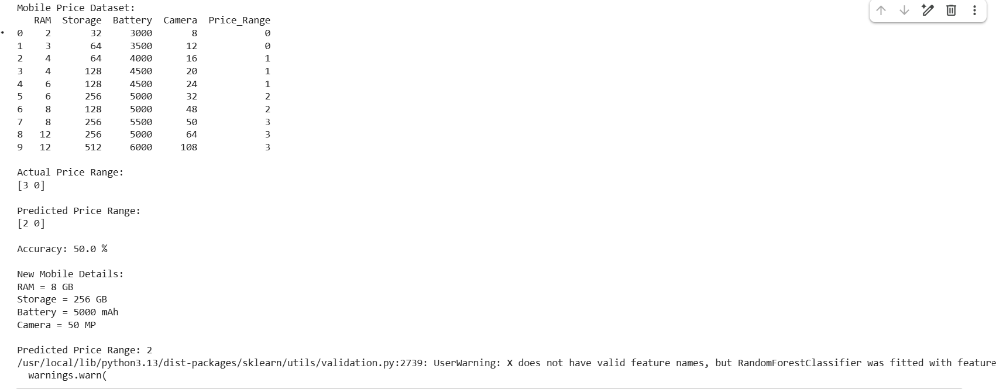

Result:
The Random Forest classifier was implemented to predict mobile phone price ranges based on RAM, storage, battery capacity, and camera specifications.

EXPERIMENT 18 – Perceptron Based Iris Classification
Aim
To implement Perceptron-based Iris classification using Python.
Algorithm
- Load the Iris dataset.
- Select two classes for binary classification.
- Select suitable features.
- Split the data into training and testing sets.
- Create a Perceptron model.
- Train the model.
- Predict the test data.
- Calculate accuracy.
Code:
from sklearn.datasets import load_iris
from sklearn.model_selection import train_test_split
from sklearn.linear_model import Perceptron
from sklearn.metrics import accuracy_score

# Load Iris dataset
iris = load_iris()

# Select first two classes
X = iris.data[:100]
y = iris.target[:100]

# Split data
X_train, X_test, y_train, y_test = train_test_split(
X, y, test_size=0.3, random_state=42
)

# Perceptron model
model = Perceptron(max_iter=1000, random_state=42)

# Train
model.fit(X_train, y_train)

# Predict
y_pred = model.predict(X_test)

print("Actual:", y_test)
print("Predicted:", y_pred)

print("Accuracy:", accuracy_score(y_test, y_pred) * 100, "%")
Output:

Result:
The Perceptron algorithm was implemented successfully and classified the two selected Iris classes with 100% accuracy on the test data.

EXPERIMENT 19 – Naïve Bayes for Bank Loan Prediction
Aim
To implement Naïve Bayes classification for predicting whether a customer is eligible for a bank loan.
Algorithm
- Create the bank loan dataset.
- Select customer features.
- Convert categorical values into numerical values.
- Split the dataset.
- Train a Gaussian Naïve Bayes classifier.
- Predict loan approval.
- Calculate accuracy.
- Display the prediction.
Code:
import pandas as pd
from sklearn.model_selection import train_test_split
from sklearn.naive_bayes import GaussianNB
from sklearn.metrics import accuracy_score

# Create bank loan dataset
data = {
'Age': [25, 30, 35, 40, 45, 28, 50, 32, 38, 48],
'Income': [30000, 40000, 50000, 60000, 70000, 35000, 80000, 45000, 55000, 75000],
'Loan_Amount': [100000, 150000, 200000, 250000, 300000,
120000, 350000, 180000, 220000, 320000],
'Credit_Score': [600, 650, 700, 720, 750, 620, 780, 680, 710, 760],
'Loan_Status': [0, 0, 1, 1, 1, 0, 1, 1, 1, 1]
}

df = pd.DataFrame(data)

print("Bank Loan Dataset:")
print(df)

# Features and target
X = df[['Age', 'Income', 'Loan_Amount', 'Credit_Score']]
y = df['Loan_Status']

# Split dataset
X_train, X_test, y_train, y_test = train_test_split(
X, y, test_size=0.2, random_state=42
)

# Create Naive Bayes model
model = GaussianNB()

# Train model
model.fit(X_train, y_train)

# Predict test data
y_pred = model.predict(X_test)

print("\nActual Loan Status:")
print(y_test.values)

print("\nPredicted Loan Status:")
print(y_pred)

# Calculate accuracy
accuracy = accuracy_score(y_test, y_pred)
print("\nAccuracy:", accuracy * 100, "%")

# Predict a new customer
new_customer = [[35, 50000, 200000, 700]]
prediction = model.predict(new_customer)

print("\nNew Customer Details:")
print("Age = 35")
print("Income = 50000")
print("Loan Amount = 200000")
print("Credit Score = 700")

print("\nPredicted Loan Status:", prediction[0])

if prediction[0] == 1:
print("Loan Approved")
else:
print("Loan Not Approved")
Output:
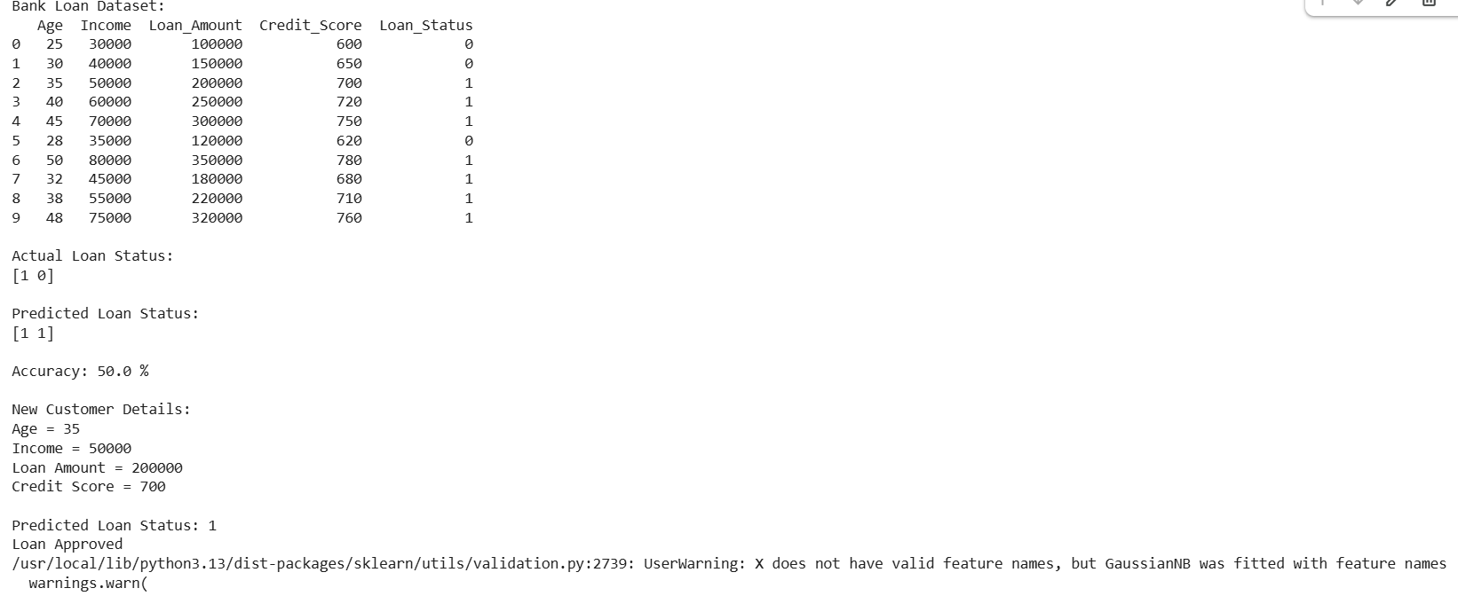

Result:
The Gaussian Naïve Bayes algorithm was implemented to predict loan eligibility based on customer details. The new customer was predicted to be eligible for loan approval.

EXPERIMENT 20 – Future Sales Prediction
Aim
To predict future product sales using a suitable machine learning regression algorithm.
Algorithm
- Create the historical sales dataset.
- Use time/month as the input feature.
- Use sales as the target variable.
- Train a Linear Regression model.
- Predict future sales.
- Display the predicted sales values.
Code:

import pandas as pd
from sklearn.linear_model import LinearRegression

# Create sales dataset
data = {
'Month': [1, 2, 3, 4, 5, 6, 7, 8, 9, 10],
'Sales': [100, 120, 135, 150, 170, 190, 210, 230, 250, 275]
}

df = pd.DataFrame(data)

print("Sales Dataset:")
print(df)

# Features and target
X = df[['Month']]
y = df['Sales']

# Create Linear Regression model
model = LinearRegression()

# Train the model
model.fit(X, y)

# Predict future sales
future_months = [[11], [12], [13], [14], [15]]
predictions = model.predict(future_months)

print("\nPredicted Future Sales:")

for month, sales in zip(range(11, 16), predictions):
print("Month", month, ":", round(sales, 2))
Output:
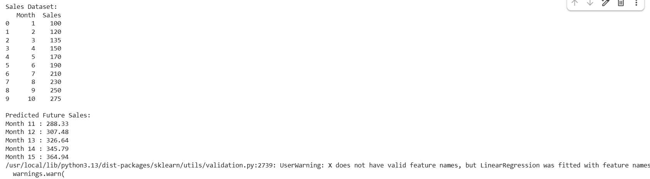

Result: The Linear Regression model was implemented successfully and predicted future sales for the next five months based on historical sales data.

